Project Report

|  |  |
| --- | --- |
| Product Name | Advanced Certificate in Web Development |
| Qualification Name (NICF) | ITSF - Advanced Certificate in Information Technology (Application Development) |
| Product Name | Front End Web Development |
| Module Name (NICF) | ITSF - Front End Web Development |

|  |  |  |  |
| --- | --- | --- | --- |
| Student name | | Assessor name | |
| Muhammad Kemal | |  | |
| Date issued | Completion date | | Submitted on |
|  |  | |  |
|  | |  | |
| Project title | Development of website for a Training Organization | | |

|  |
| --- |
| Learner declaration |
| I certify that the work submitted for this assignment is my own and research sources are fully acknowledged.  Student signatures: Dates: |

Content

1. Project background
2. Project Objectives
3. Requirements Specifications
4. Task 1
5. Task 2
6. Task 3
7. Task 4
8. Task 5
9. Task 6
10. Task 7
11. Task 8
12. Task 9
13. Task 10
14. Task 11
15. Task 12
16. Task 13
17. Task 14
18. Task 15
19. Task 16
20. Task 17

Project Background

You have been approached by 'ABC Learning Center' as a website developer to develop a website for their institute. 'ABC Learning Center' is an IT Training institute that conducts courses like 'Programming in Java', 'Programming in .Net', 'Microsoft Office', 'HTML' etc. They want to design a website which can be used for providing information about their courses to students and for capturing leads generated by digital marketing. Project Brief – ITSF Front End Web Development Page | 2 You will be required to design and develop this website using HTML, JavaScript, CSS, jQuery & Ajax.. You will be required to design following pages in this website

Project Objective

• Plan a Website & Develop branding, wireframes, information architecture & storyboard

• Develop a website using HTML, CSS & Javascript.

• Develop jQuery Menus & Tabs

• Designing a form using HTML, developing javascript to validate the form and submit the form using Ajax. • Execute the test cases and validate the website meets the design requirements.

Tools & platforms used

1. Windows 10/window 11
2. Visual Studio Code
3. Google chrome
4. Xampp
5. Apache 2.4

Requirements Specification

1. Common Content
   1. header
   2. Footer
   3. Navigation
2. Home Page
3. About Us Page / Profile Page
4. Course Listing Page (Listing 2 Courses at least)
5. Course Details Page (Develop 2 pages, 1 for each course)
6. Course Schedule Page (Develop 2 pages, 1 for each course)
7. Contact Us Page (Develop 1 Html page)
8. Lead Registration Page (Develop 1 form)
9. Registration Thank You Page ( Develop 1 HTML page)
10. Sitemap Page (Develop 1 HTML page)
11. Privacy Policy Page (Develop 1 HTML page)
12. Tax 1
13. Functional Requirements
14. Home page

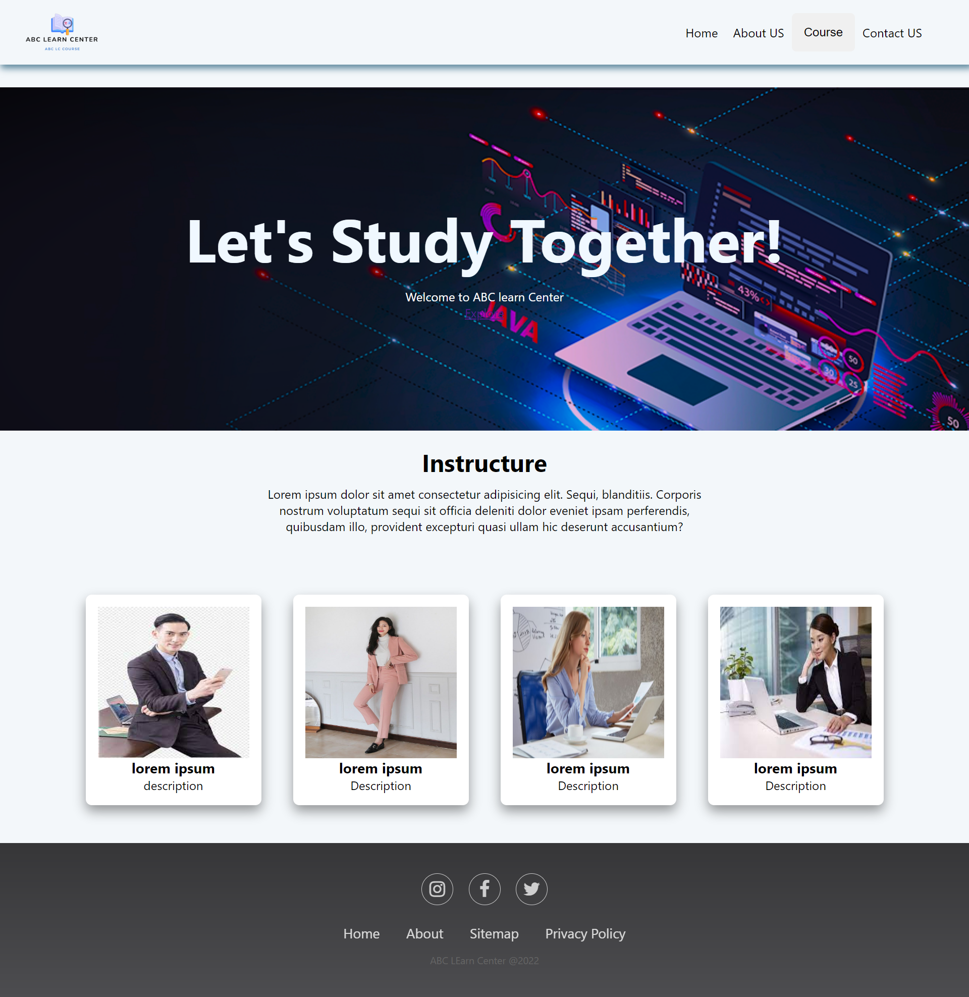

* • Inside this home page contains a navbar which will lead to another page. It also includes home content including a welcome to let users know if this is the main page of the ABC LEARNING CENTER website. This home also displays all the teachers who will teach the course and details about them. The last one is the footer where there are social media pages as well as sitemaps and privacy policy.

Inside this home page contains a navbar that will lead to another page. It also includes home content including welcome to inform users if this is the main page of the ABC LEARNING CENTER website. Next, the content listing page shows what popular courses are in this ABC LEARNING CENTER and can go directly to the destination page when you press,

This content get experience is for users if they are interested they can join directly by pressing Start know. The last one is the footer where there is a social media page as well as a sitemap and pripacy police.

1. About page

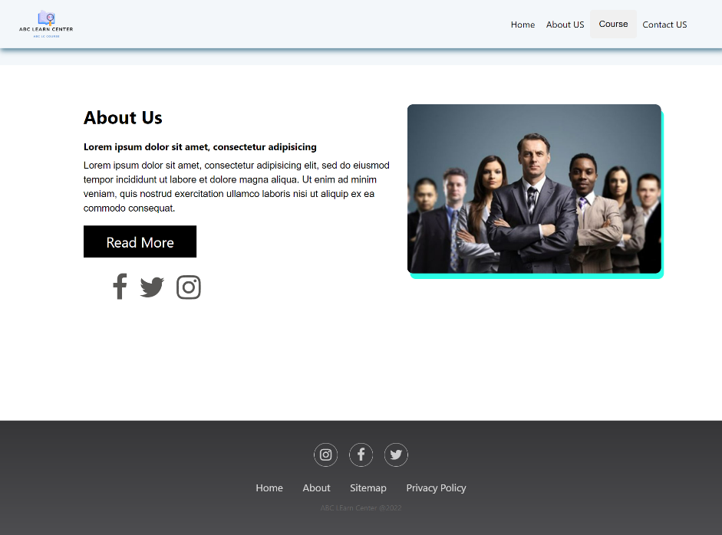

* In this about page, it contains about success with ABC Learning center which invites users to join the ABC LEARNING CENTER course, also explains about teaching programming courses including html, java, and Microsoft. Also lastly, there are teams that work in the ABC Learning Center.

1. Contact page

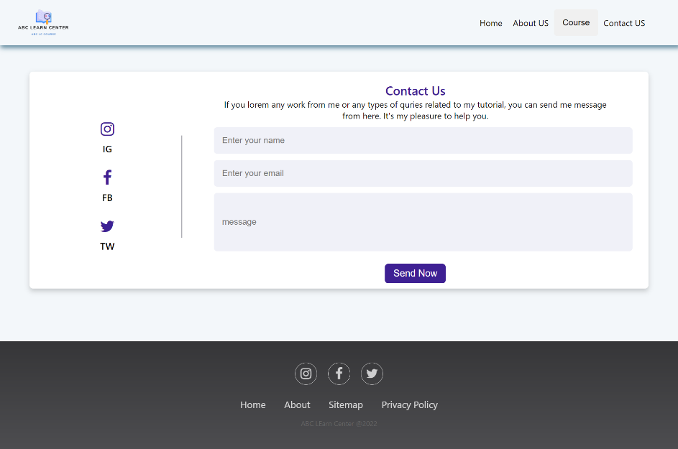

• On this contact page there is the first content, namely send message to send a message to the admin email address, and there are also related social media in it such as twitter, instgram and facebook are also available, the address is the complete address where the ABC Learning center is located

1. Course Listing

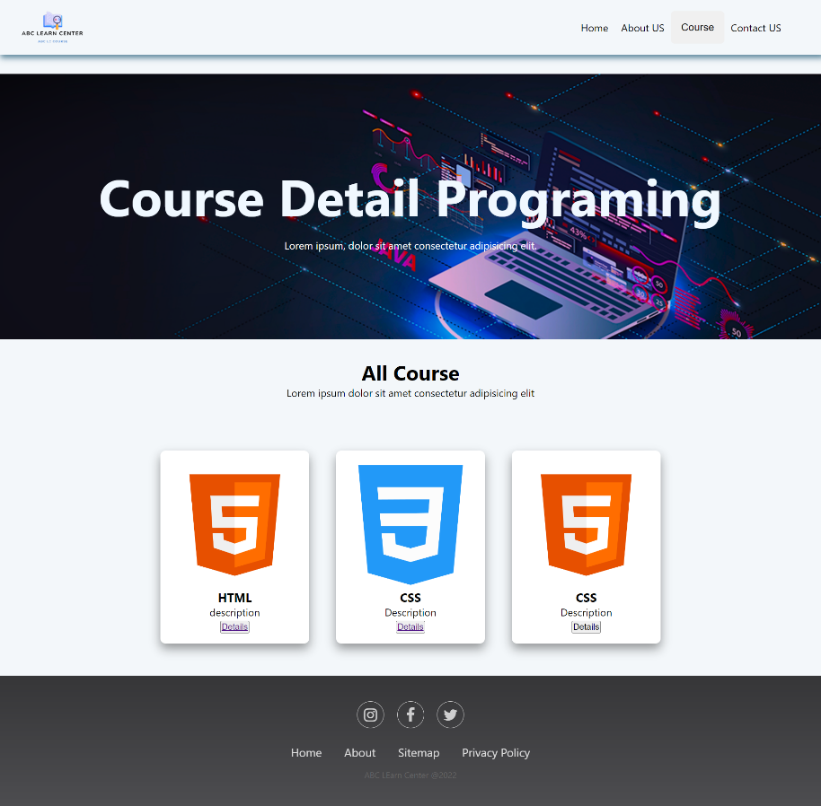

* This listing page is for selecting courses that are already listed on this listing page and see more details.

1. Course Details

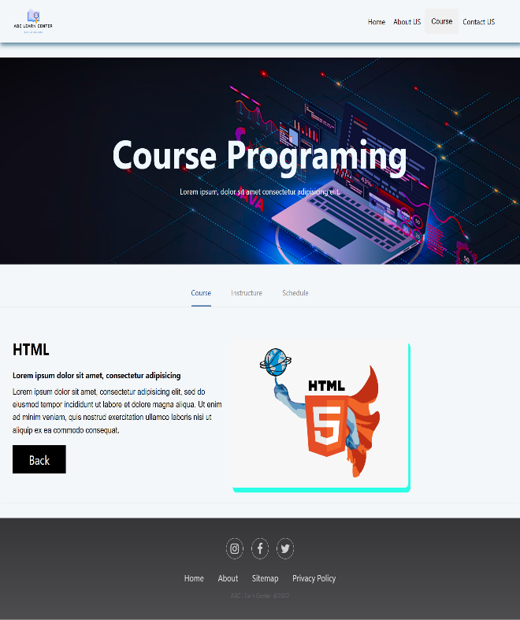

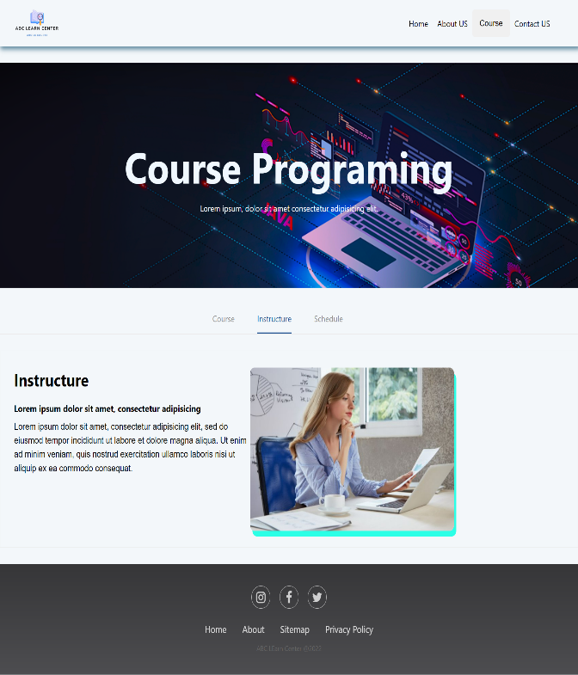

• In this course there is an overview as well as a theory that explains why we should study this course, its advantages. material for us to see the material that will be studied in the course. And finally there is a mentor provided for each course at the "ABC LEARNING CENTER", and we can go directly to it when we press the "Go Schedule" schedule page

1. Course Schedule

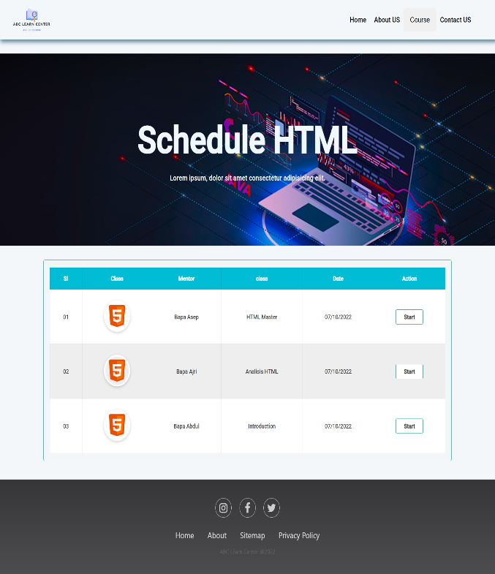 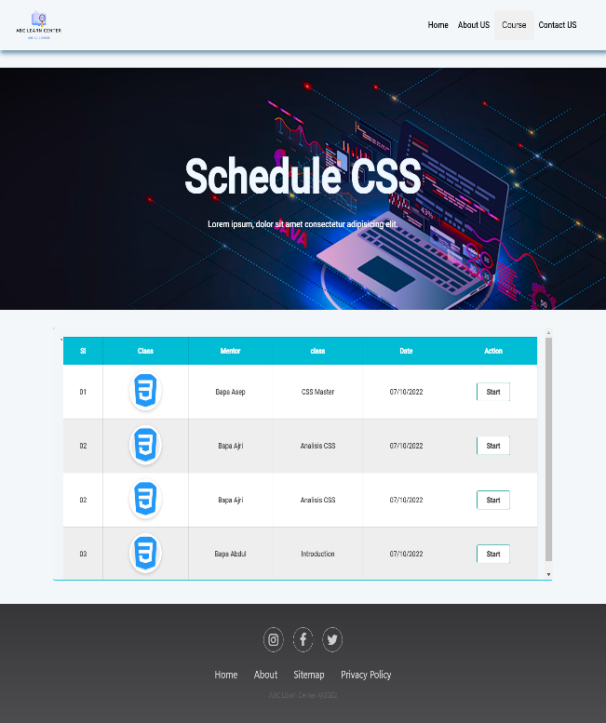

• In this course schedule there is the name of the supervisor and a list of schedules where the book can see the contents of the schedule that we choose. Also the last is if we press the start button we will be directed to start the course according to schedule.

1. Sitemap

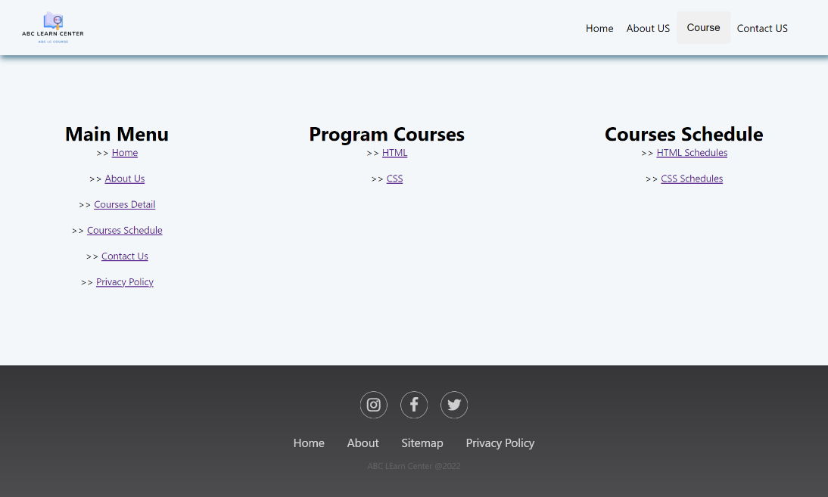

* This is a sitemap page for any links on the ABC Learning Center website.

1. Privacy policy

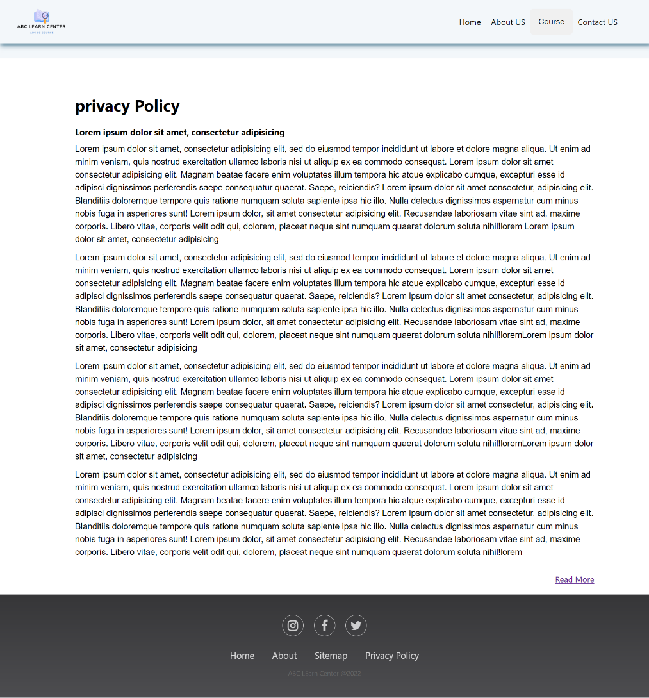

* page Privacy policy is a statement or legal document that discloses some or all of the ways in which a party collects, uses, discloses, and manages customer or client data.

1. Register page

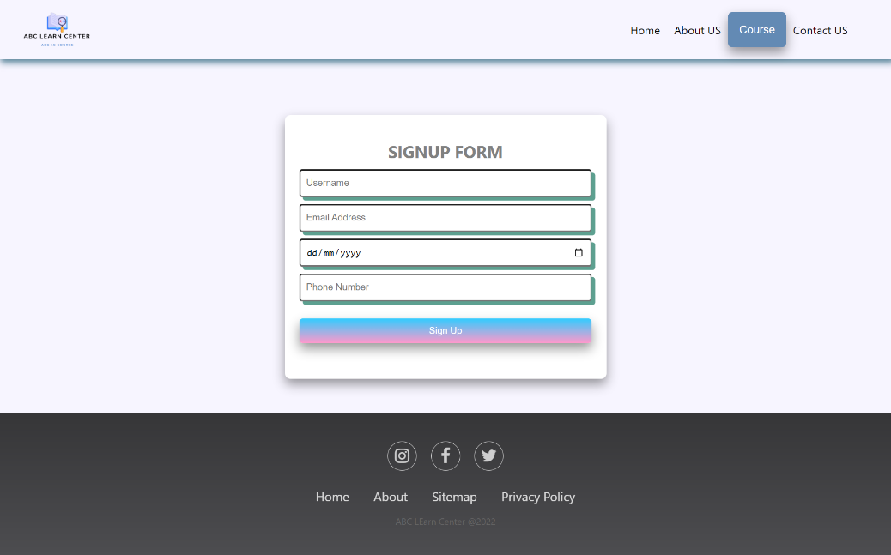

* Register page is to register with us and will get a more complete course. In the register we need to fill in, among others, email, username, contact number, course, and address.

1. Thank page



* Thank you page, that is, after we complete the registration, we will go to the thank you page.

1. admin page

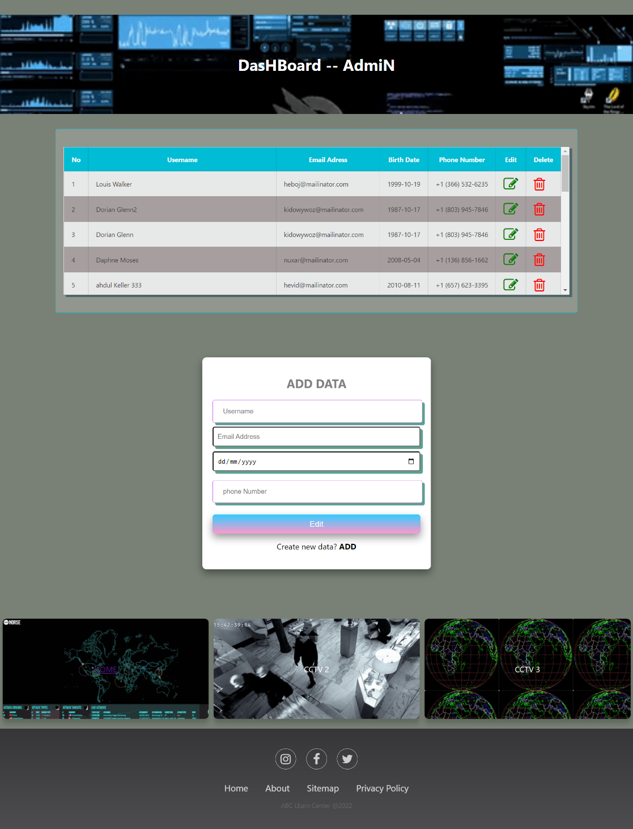

* In this admin page there is a crud where the table is added, edited, deleted, and the form is add data and also edit data.

2. Non-functional requirements

a. Usability

- Easy to navigation

- Site easy to use

- Interaction with the site is quite clear and understandable

b. information

- Provide clear information

- Provide Detailed Information so that users can understand easily

c. Compatible

- The website is compatible with your web browser like google, chrome, mozila, Microsoft edge etc.

d. Link

- All links on website are working properly

3. Technical Requirements

* Web Server: Apache/Visual Studio/xampp.
* Client/Web browser : Chrome/Microsoft Edge.
* Operating System: windows
* Code Editor : Visual Studio Code.

Task 2

1. Create an Information Architecture & Storyboard for the website

2. Propose the Information flow for a Leads generation form & Its Administration (Login Not Required)

a. User must be able to Add, Edit, Delete & List leads

* + Information Architecture:

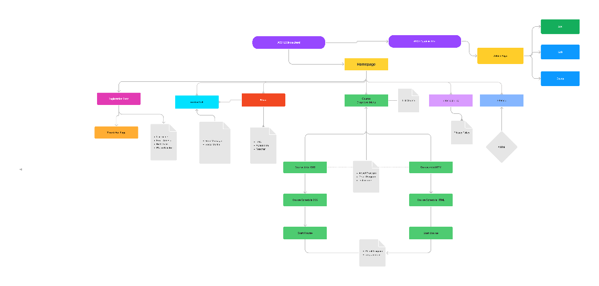

* + B. Storyboard for the website

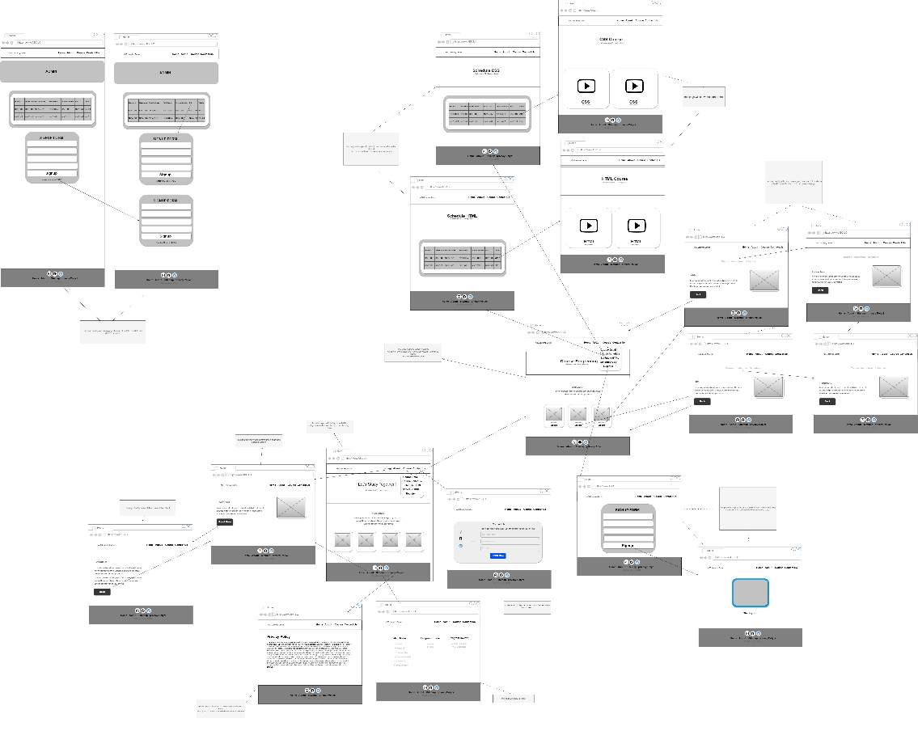

Task 3

-Develop the HTML Pages required for the website

-Develop the Lead Generation Form & Administration System pages for Lead Generation form management.

- Include the screen capture as part of Project Presentation

* + Lead Generation Form

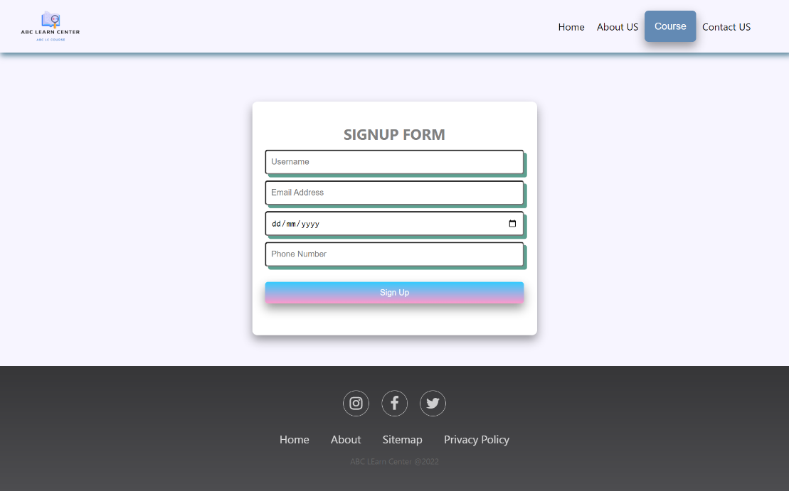

* + Administration System Pages

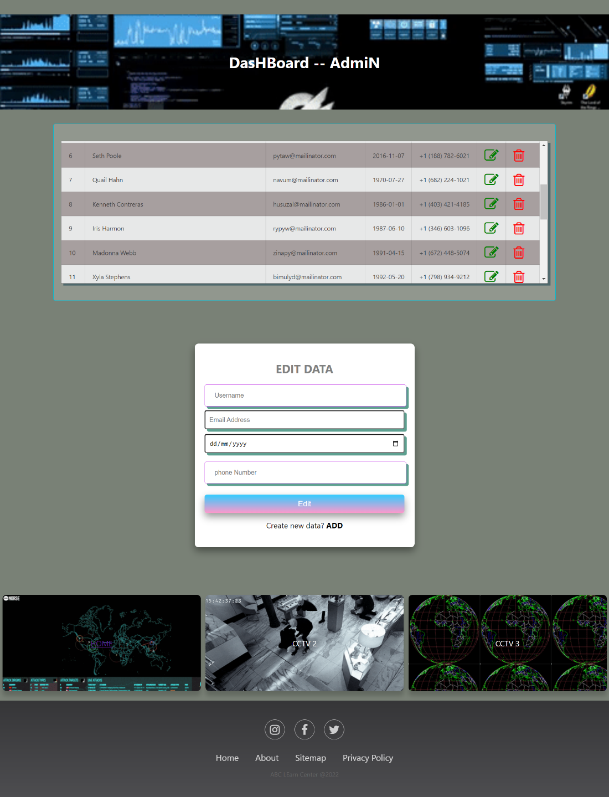

1. Task 4
2. Dropdown

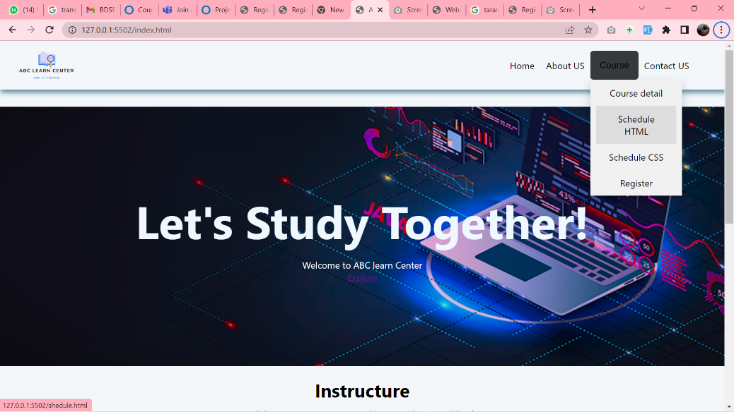

1. Tabs menu

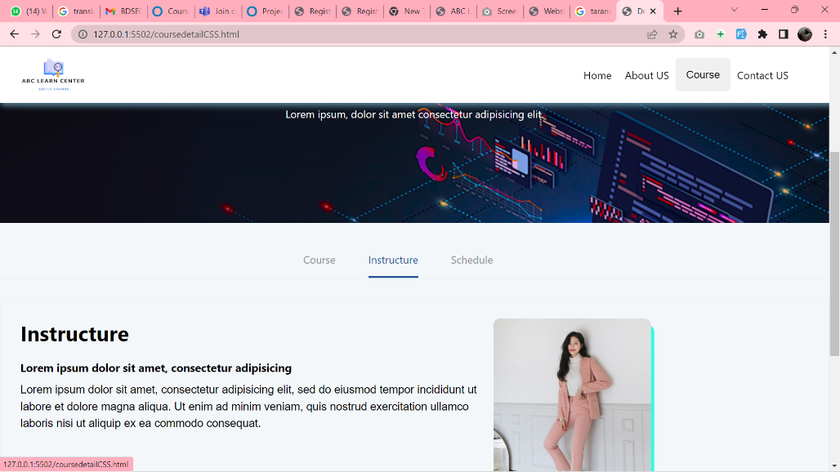

1. Task 5

My form needs to be able to remind the user of a mistake they have made before submitting or proceeding. Errors should be displayed in such a way that it is easy for the user to find the error and fix it, also the user can go directly to the thank page without any problems. It will therefore improve the integrity of the data we receive from users.

My form should able to show errors before submitting when there are some errors. so that the user can understand and correct the wrong input, it will improve the integrity of the data we receive from the user.

1. Form validation-

Its is checking for valid email and contact number.

1. Proper description of the error

Errors are displayed in a helpful way. So that it becomes easy for the user to debug and fill proper input.

1. Task 6
2. his validate for gmail when user not used @ so this user can't input email appropite.

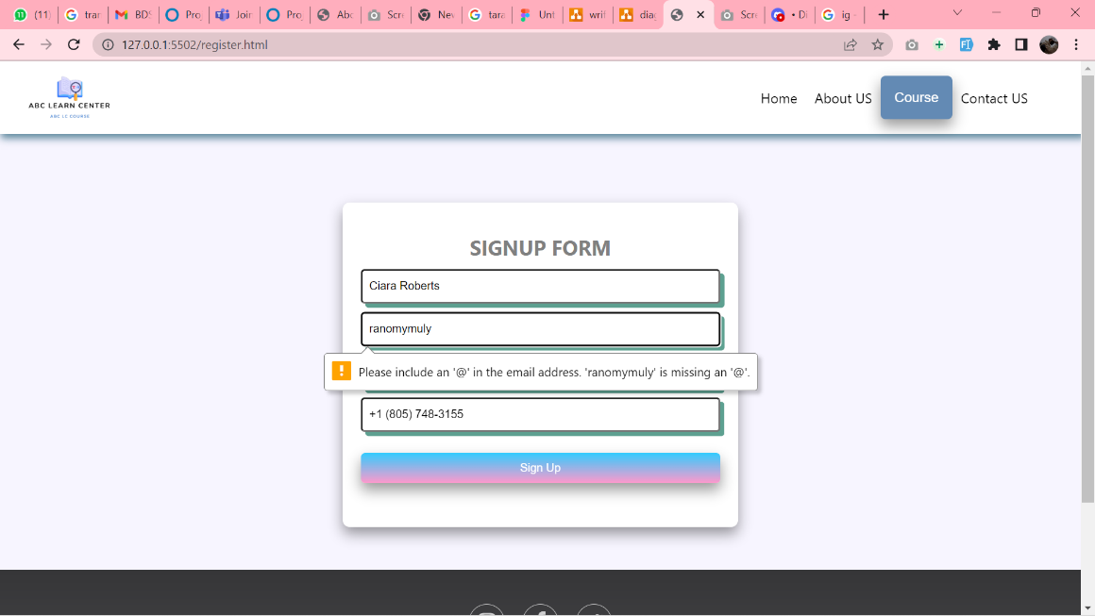

1. This validate for gmail when user duplicate name gmail users.

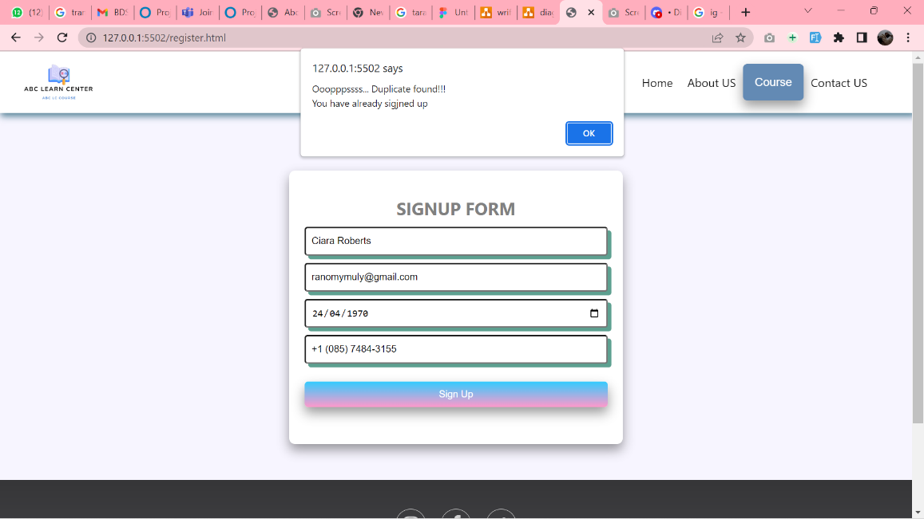

1. Task 7

User Guide

* Create a User Guide for Lead Generation form and its Associated Administration Module
  1. Installation

Ways to run the application include:

1. If it appears "it's work!" we type[http://localhost/vhosts/ABC-LC /](http://localhost/vhosts/ABC-LC%20/)

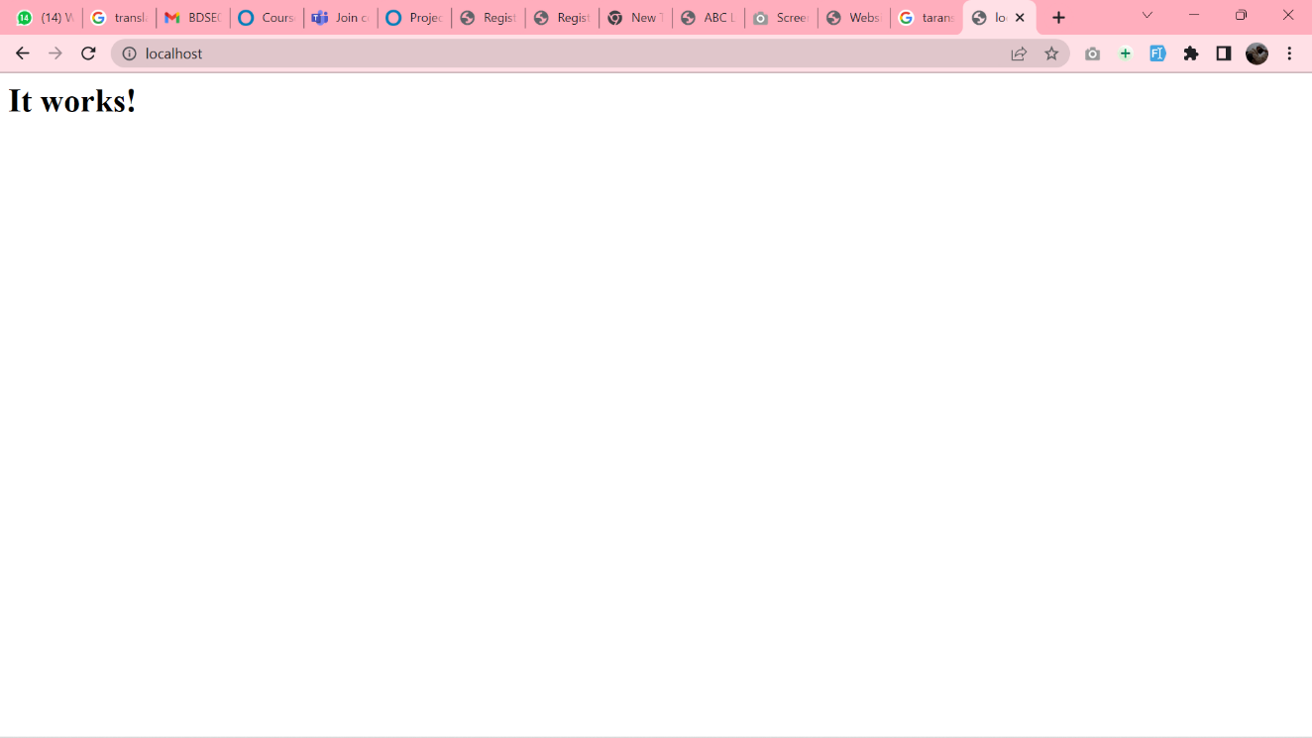

Write localhost/vhosts/ABC-LC web in search page.

1. Congratulations, you have successfully run the ABC LEARNING (ABC-LC) Application.

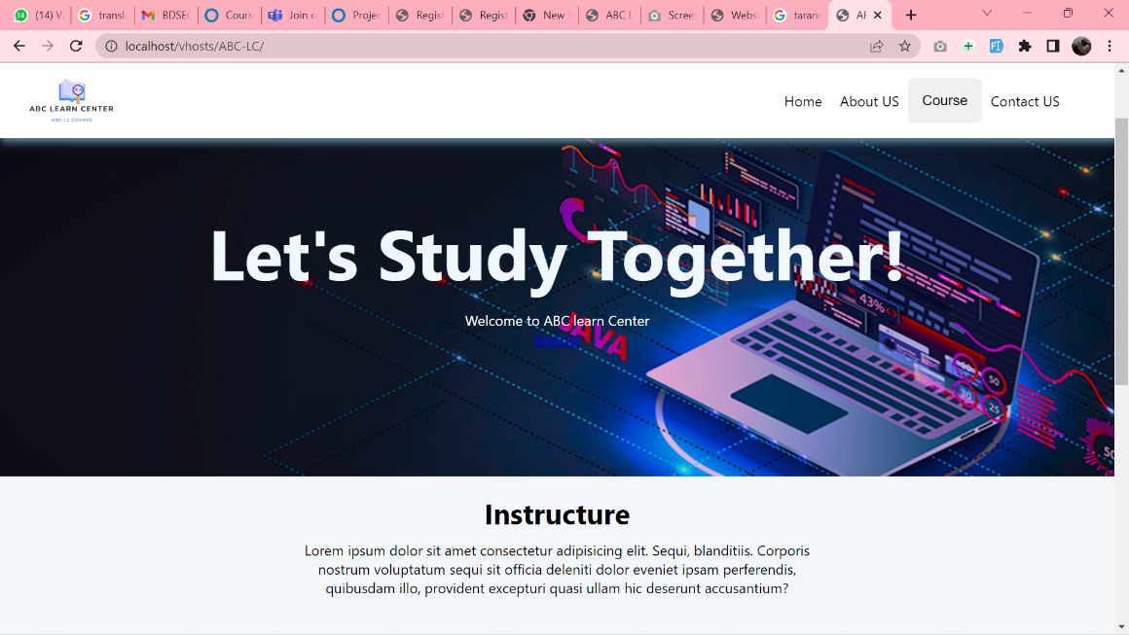

* 1. Lead generation form
     + 1. User can access link From URL register.html
       2. In this page we can register by filling all the input.
       3. When we have mingis all forms correctly and validation is correct
       4. An alert will appear that the user is already registered in the local storage and will be taken to the thank you page.

C. Admin system page

1. In this admin page, all data in local storage will be read also in local storage, there are add, edit, and delete. Only this admin page cannot be accessed on the main page. But it can be accessed by changing the URL link to admin.html

1. Add data is used to add new student new data, you can press the add button and an add form will appear and there you can add new student data. In the following way:

A. Click Button Add.

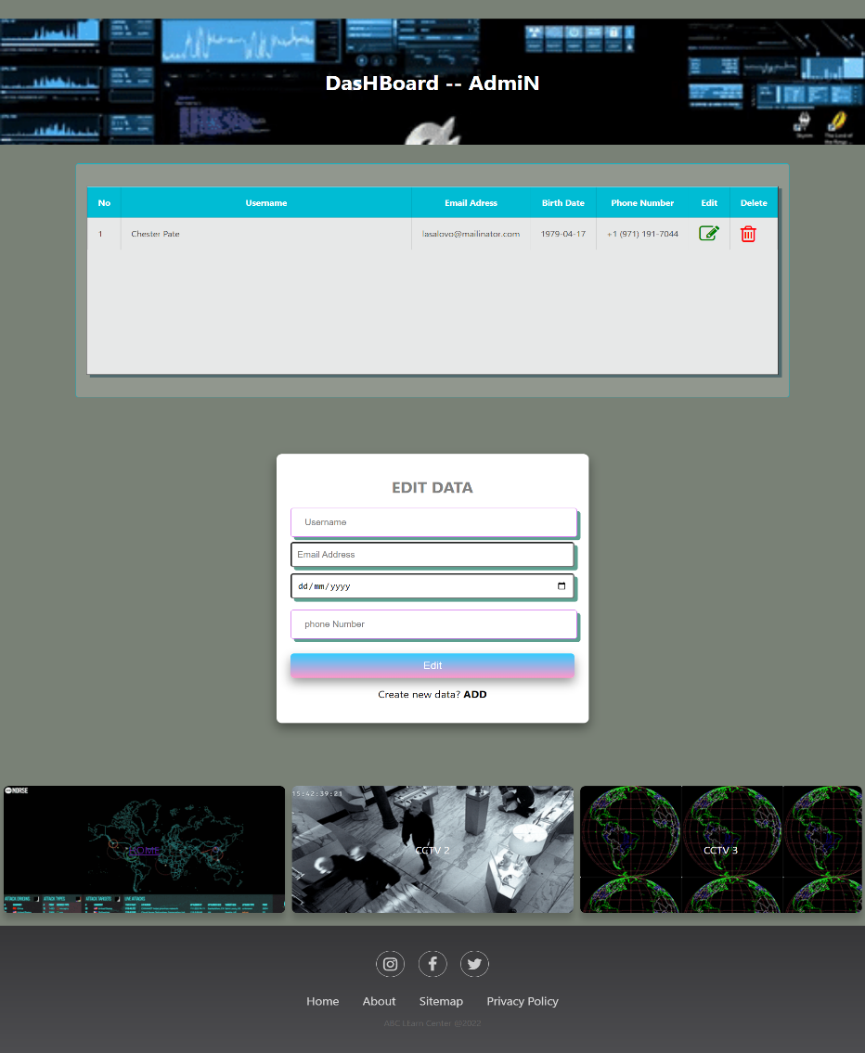

B. An add form will appear

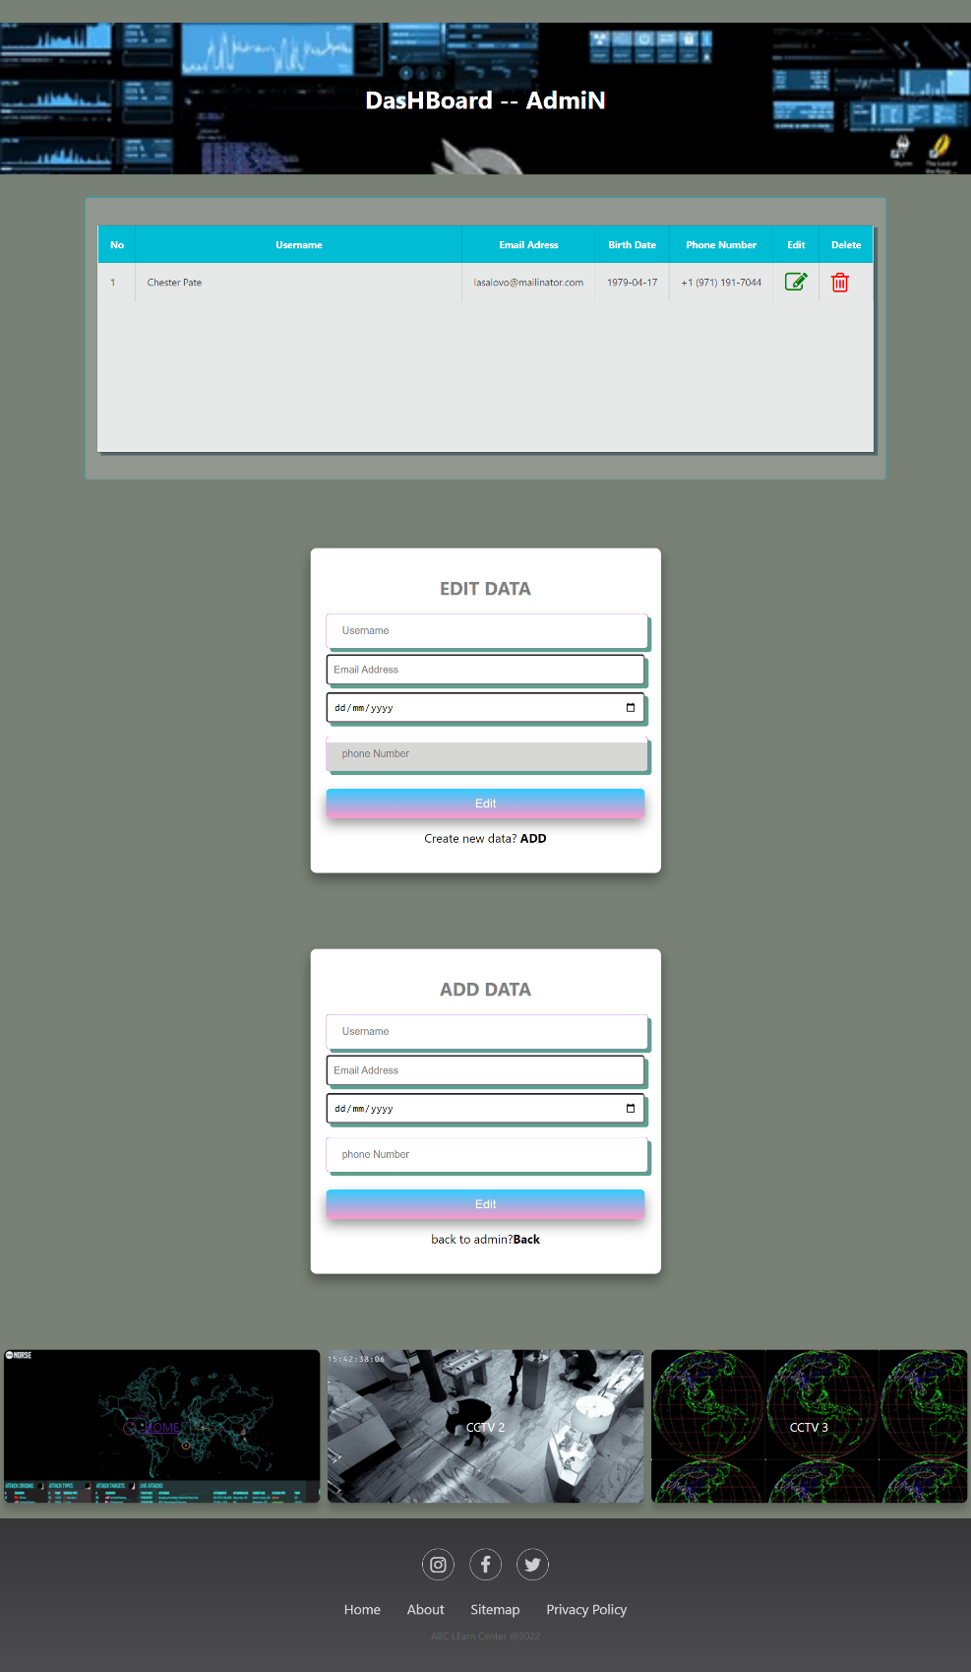

C, When you fill in all input and will show the alert that you create data success.

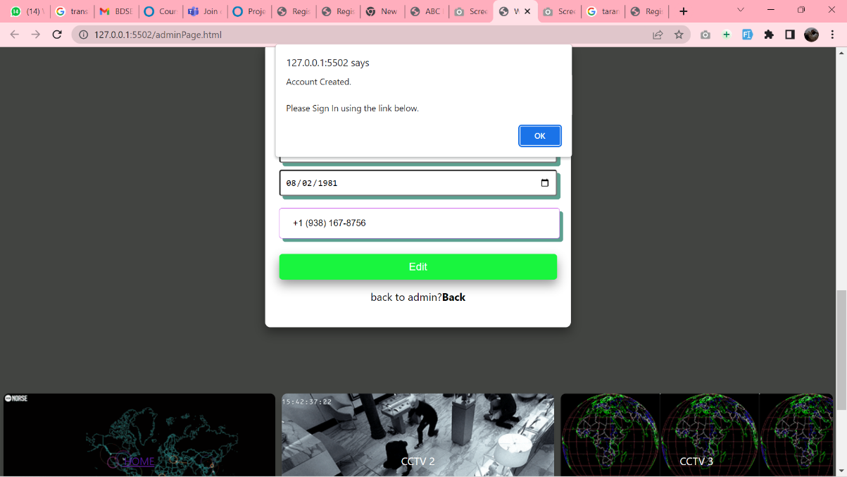

1. Edit data is used to update table from local storage.
   1. Click the edit button

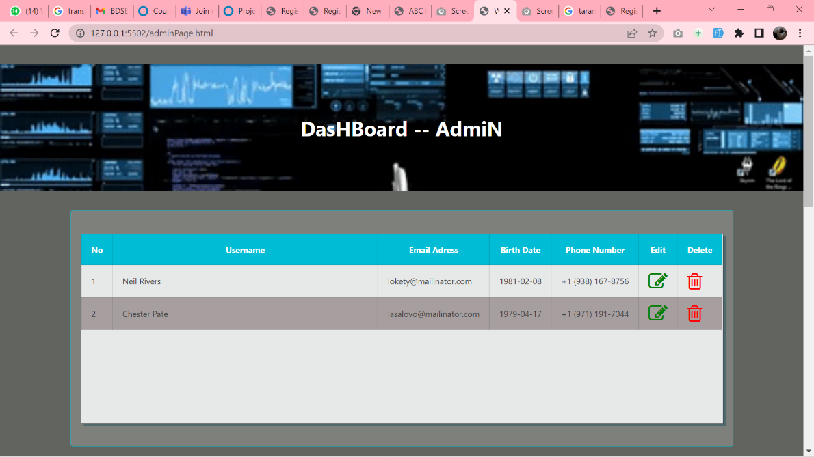

B. will to show the edit form and An edit form will appear

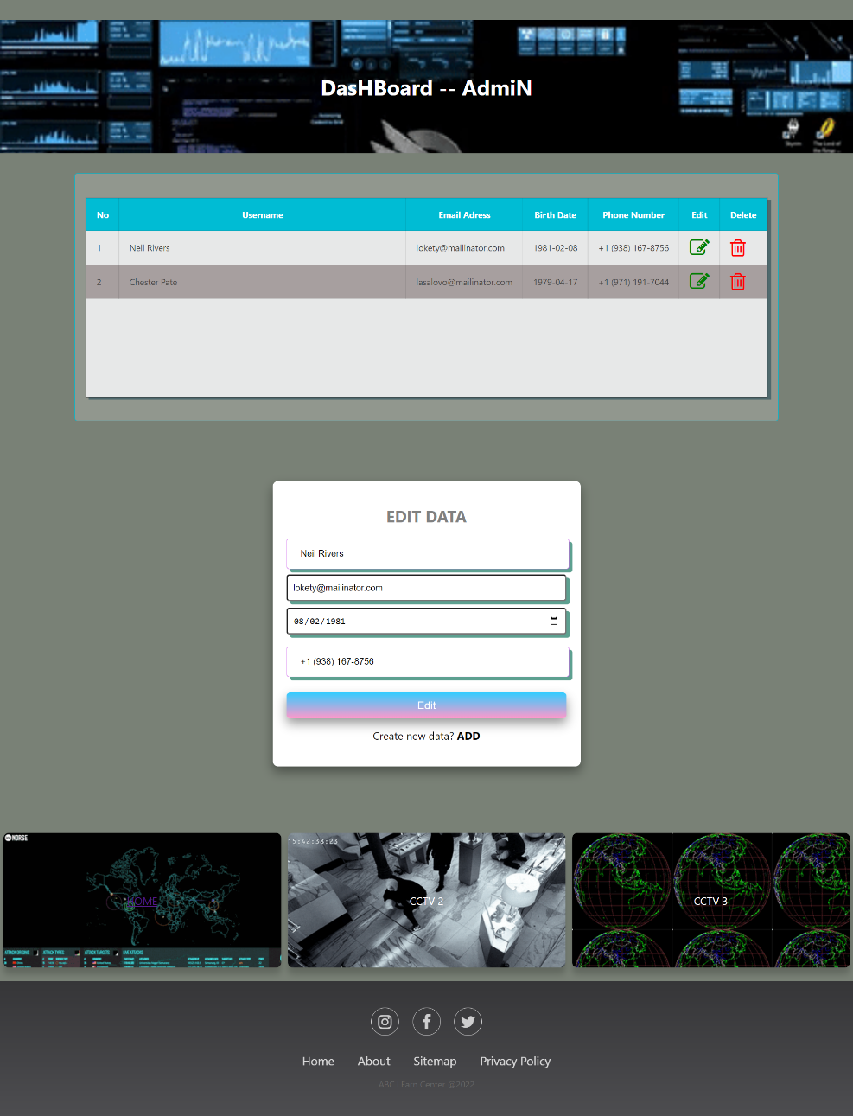

* Delete data is used to delete user data that is in the local storage admin.
* Click the delete button.

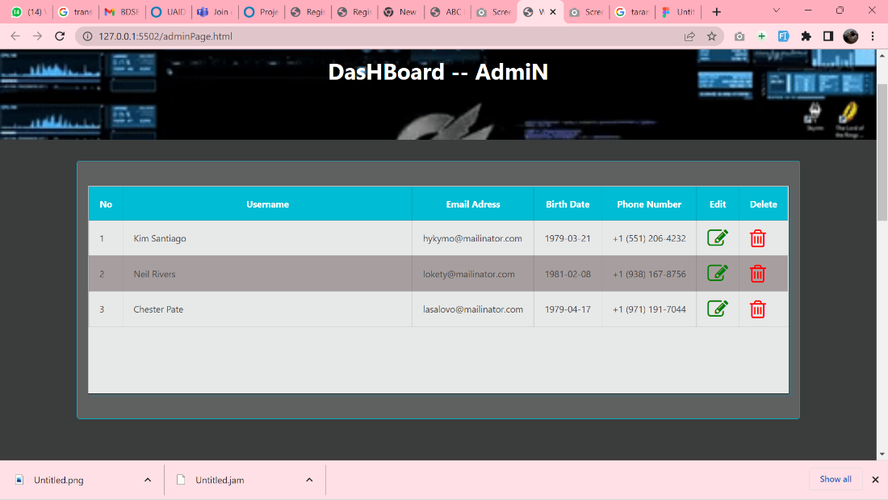

B. When will appear pop up alert “Are your sure want to delete this data? “. Then choose yes or no so data will automatically disappear

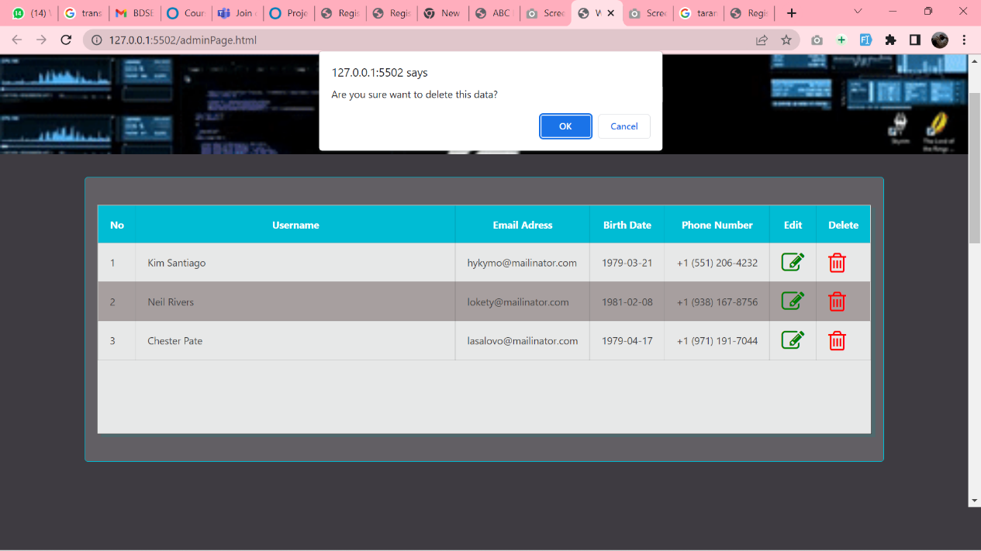

**Source reference website :**

* Website lithan.
* W3School.
* You Tube.